Project Management

Project management is a very broad term but it is used throughout industries such as the restaurant industry all the way up to the IT industry. Being a Project Manager/leader is a very important job to have as it requires you to have good leadership and social skills. Project managers have to be good in so many aspects in order to be effected for their team such as being organized, having a good mindset, being able to work under pressure, being able to handle a workload the list goes on. Being a good and effective Project manager is not easy as it comes with a lot of responsibility but if you can handle all the responsibility you will excel as a good project manager. As a whole Project Managers I used in a variety of ways whether it’s in a scrum meeting or a restaurant team meeting project managers all have different projects and gameplans that they need to take care of. When it’s all set and done it’s all about perception and willingness to succeed.

A key factor that’s important when being a project management is being social. You have to be comfortable with interacting with your peers and customers when you are a project manager. It’s all about setting an example for your team that you are confident and very well spoken. Confidence is really the key when you are interacting with others. In order to be a good Project manager make sure you follow helpful tips, hints, and demonstration to help you better yourself has a good project manager. It is always helpful to use your resources so you can improve and if you think you know everything then that means that you don’t. Don’t try to 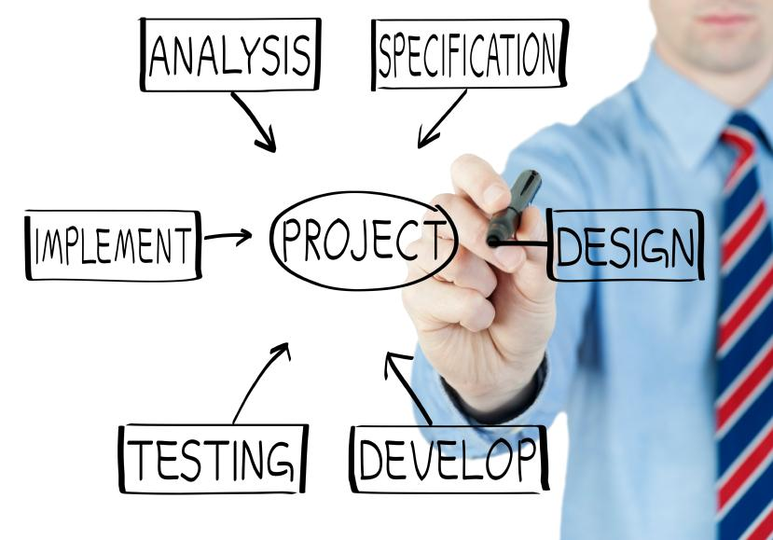

be cocky and think like you it all because there is a difference between being cocky and being confidence do not confuse the two.

**Project Management Do’s and Dont’s**

**What to do-** Make sure you follow these tips to be a good and effective project manager.

**Always have a game plan-** When you are a project manager you always want to make sure that you have everything together and you come prepared with a plan.It’s always best to figure out a good approach to a task before you start it.

**Develop a team**- When you are project manager you always want to make sure you gather up your best team for the task at hand. The project manager is responsible for assigning roles for everyone on the team so that everyone knows their job.

**Implement a good system-**  When you are doing a task you want to implement an effective system that can easily get the job done. The chart to your left shows an example of a way to implement a good system. If you are able to implement a good system then your team will be smoothly rolling 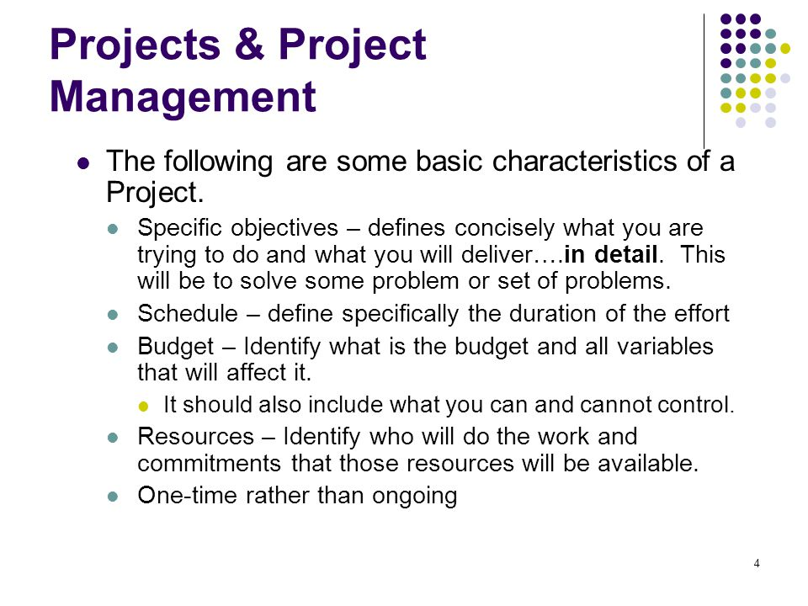

**Always be confident and have a backbone -** Like I said earlier before confidence is key when being a project manager so that shouldn’t change here. Make sure that you always are confident in everything that you do with your team. It will be bad for your team if your team see you discourage or frustrated with a job so try your best not to get frustrated. Also when being a project manager it’s your job to make sure that your team is always in line meaning that they must respectful to you as their leader and to their team and if they are not make sure you get them in line do not make them run over you.

**What not to do-**  Make sure you avoid doing these at all cost

**Lack of urgency-** If you show no sense of urgency or commitment to your job then you shouldn't be a project manager. Showing a lack of urgency is vital and it can ruin your team's chemistry.

**Bad social skills**- As a project manager you have the ability to socialize that’s just what you have to do. If you’re not able to socialize then you’re not able to have good communication with your customers. Communication is key when being a project manager if you don’t know how to do anything else you must be good at communicating.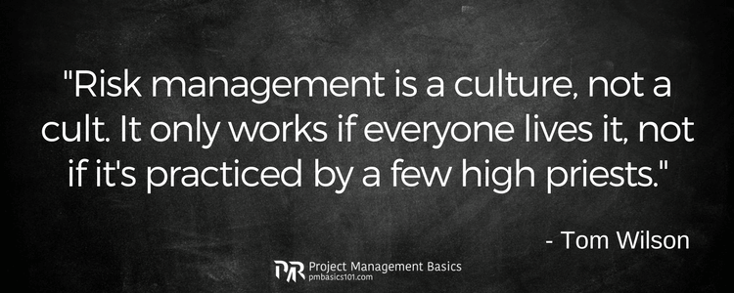

**Disorganized-** When being a project manager you can’t be disorganized. Being disorganized can throw off your whole project in a matter of seconds. You must avoid that, you always always always have to be well organized and on top of your game. You won’t be able to get the job done if you dysfunctional as a project manager.